Course work

COMP1649:

HUMAN-COMPUTER INTERACTION & DESIGN

**Student name: Ly Hue Huan**

**Student ID: 001353731**

Table of Contents

I. Introduction 5

II. Background requirements analysis & justification 5

III. Literature review 5

A. Interaction design 5

B. Human-computer interaction 5

1. Define 5

2. Components of HCI 6

3. The importance of HCI 8

4. The process of interaction design 11

IV. Product design goals 12

A. Overall my design 12

B. Conceptual design 15

1. User requirements 15

2. Color palette 20

C. First designs 22

1. Hand-drawn manuscript 22

2. Device sketch 25

V. Final design 26

A. Physical device 26

B. Axure design 27

1. Dive computer 27

C. Take feedback 49

VI. Conclusion 50

A. Accomplished 50

B. Limitations/Omissions 50

C. Things that can be improved/Foresight of the project 50

VII. References 51

Figure 1 Group of coder on Facebook 6

Figure 2 Car go up slope 7

Figure 3 Monitor screen of a motorbike 7

Figure 4 light colors (Rid, 2023) 8

Figure 5 dark colors (Rid, 2023) 8

Figure 6 HCI in medical 9

Figure 7 Disabilities people 10

Figure 8 HCI is very important to the software manufacturing industry 10

Figure 9 Old-user and technology product 11

Figure 10 Interaction Design Process 11

Figure 11 Current Dive computer 12

Figure 12 Current Dive computer 13

Figure 13 My Dive computer 14

Figure 14 Inside an Apple watch 15

Figure 15 Survey 16

Figure 16 Survey result1 17

Figure 17 Survey result2 17

Figure 18 Survey result3 18

Figure 19 Survey result4 18

Figure 20 Survey result5 19

Figure 21 Tra's request 19

Figure 22 LyLy's request 20

Figure 23 Color palette 21

Figure 24 Formal icons every body known 22

Figure 25 Dive computer screens 23

Figure 26 Phone app screens 24

Figure 27 Front of device 25

Figure 28 Behind of device 25

Figure 29 Phone 26

Figure 30 Dive computer 27

Figure 31 UnDive screen 28

Figure 32 Main screen 28

Figure 33 Dive screen 29

Figure 34 Warning 30

Figure 35 Float up surface 30

Figure 36 Go to connect 31

Figure 37 blt off 32

Figure 38 mb blt on 33

Figure 39 dc blt on 34

Figure 40 both blt on 35

Figure 41 connectRequest 36

Figure 42 connectRefuse 37

Figure 43 Album phone 38

Figure 44 Choose photo 39

Figure 45 Choose video 40

Figure 46 Dive history 41

Figure 47 Back to album 42

Figure 48 Back main screen 43

Figure 49 Set max depth 43

Figure 50 M.depth 28m 44

Figure 51 Changed 44

Figure 52 Camera 45

Figure 53 Saving photo 45

Figure 54 Save done 46

Figure 55 Recoder 46

Figure 56 Recording 47

Figure 57 Saving record 47

Figure 58 Saving done 48

Figure 59 Album1 48

Figure 60 Album2 49

Figure 61 Back to dive screen 49

Table 1 Problems statement and solutions 20

Table 2 Feedback 50

# Introduction

This is a report on the diver support system. The report will cover the theory and user experience of current dive computers. From there, we offer advantages and disadvantages, ways to overcome and upgrade. Finally, create new products to meet the needs of divers.

# Background requirements analysis & justification

In the past, exploring the world under the deep ocean was an extremely dangerous job, requiring excellent water vapor retention and strong health to be able to participate in dangerous underwater exploration trips. water . Therefore, divers are still very limited in their trips. But today, with the rapid development of technology, diving support devices are discovered with a variety of brands/models. Thanks to that, ocean exploration is increasingly growing/popular and becoming safer. Humans can dive deeper and longer, which helps humans find mysteries beneath the vast ocean.

The development of diving computers provides divers with information about depth and the number of pauses needed to surface, making it easier to calculate the ascent path. Accurate calculations can greatly reduce the risk of developing decompression sickness after a diver spends time underwater. In other words, dive computers allow you to make the most of your time on the ocean floor while remaining safe both below and above. (Murphy, 2018)

# Literature review

## **Interaction design**

According to (Kolko, 2010) Interaction design is the creation of interaction between people and products (machines, services, etc.) Interaction design is the enhancement of user experience by dividing interactions and manipulating tangible elements. This is based on observation and getting opinions from users to collect, analyze and make recommendations, reasonable plan.

## Human-computer interaction

### Define

Human-computer interaction (HCI) is considered the result of a blend of many fields: psychology, social science and computer science (Carroll, 1997) Researchers always try to improve the user experience in the most reasonable, scientific and natural way, the large amount of knowledge makes it a field to learn and exploit.

In contrast to UX design, HCI is primarily focused on research and academia and will be in charge of creating new apps, goods, or services that are person-centered. In other words, HCI will mostly concentrate on creating the empirical user knowledge that subsequently guides UX designers. For this reason, HCI serves as a portal to the future of user experience.

### Components of HCI

#### User

An individual or group of persons with the same goal is referred to as a user here. User demands, objectives, and interaction patterns are studied by HCI. It examines a number of factors, including user experience, emotions, and cognitive capacities, to give users a smooth and seamless computer system interaction.



Figure Group of coders on Facebook

#### The goal-oriented task

The user makes a request for a clear task. The computer then executes this request, this is human-computer communication

For example: the user wants to use his car to go up a slope as quickly and safely as possible. The user presses the accelerator pedal, the car's ICU will automatically calculate to give the appropriate gear and engine rpm level for the car. reach the top of the slope at the speed the user wants

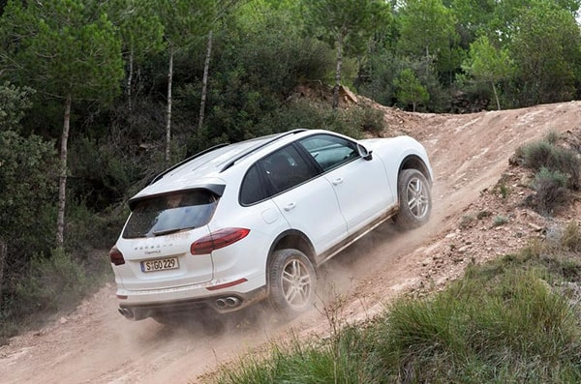

Figure Car go up slope

#### The interface

Interface is the layout, position, size, color, etc. Of components that enhance user experience

For example: Below is the monitor screen of a motorbike. The gear layout, rpm and speed are very clear to see, while parameters such as odometer, temperature, and fuel consumption will be smaller.

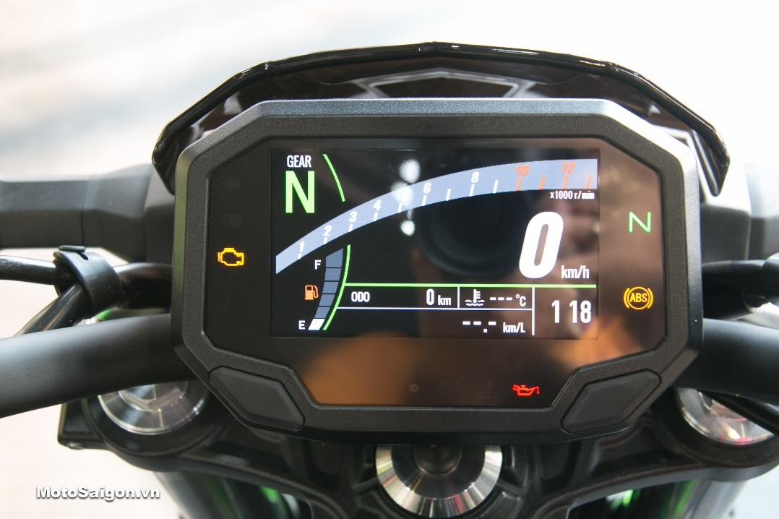

Figure Monitor screen of a motorbike

#### The context

Context includes environment, time, location, etc. Users who use the product in different contexts will have different needs.

For example: Below are 2 ways to use different colors of motorbike watches. During the day, users can use lighter colors theme to make it easier to see (figure 4). At night, users can switch to dark colors theme to avoid being dazzling (figure 5)

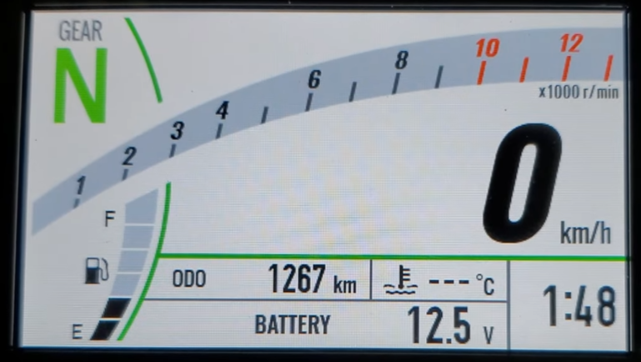

Figure light colors (Rid, 2023)

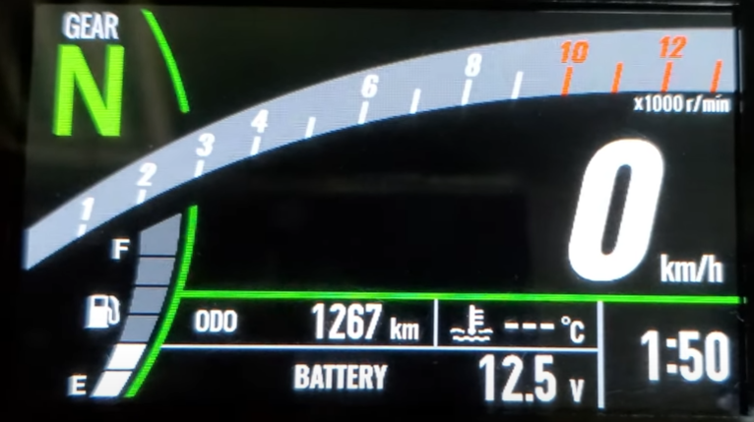

Figure dark colors (Rid, 2023)

### The importance of HCI

The importance of HCI has been recognized over time, and intangible research and inventions for HCI are also very developed. For example: (Adams & Lunt, 2008). Communities lacking formal training and understanding in engaging with computer systems might benefit from human-computer interaction.

#### In daily life

These days, technology permeates our everyday lives and has an impact on our daily routines. There are several approaches you may use to get acquainted with HCI technology.

Based on (Francisco Nunes, 2015) We can see that the healthcare industry also needs the development of technology, and HCI also goes hand in hand with this relationship.

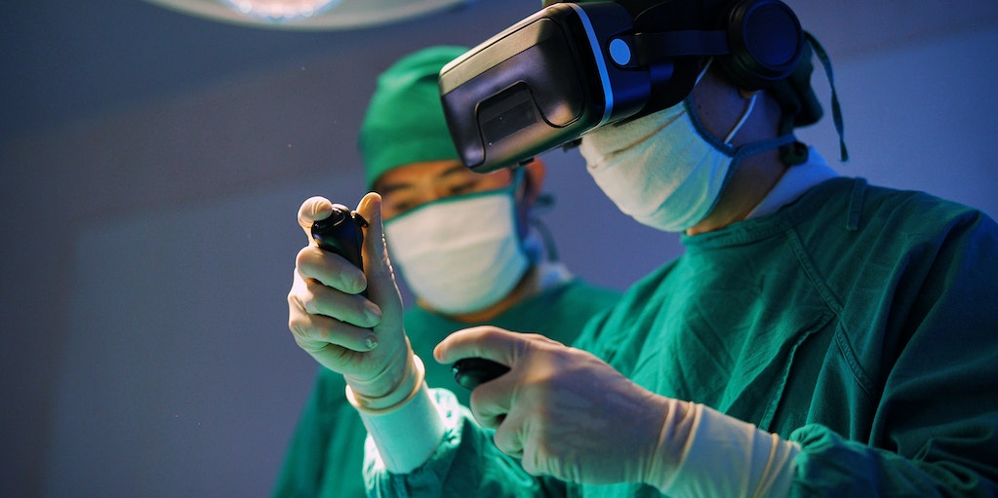

Figure HCI in medical

#### In technology

Businesses that rely on computers for day-to-day operations frequently see HCI as an essential component of their operations. A well-crafted system guarantees that workers are at ease utilizing it for their regular tasks.

HCI makes systems simple to use, even for employees without formal training. When designing secure systems, like those found in power plants or air traffic control (ATC) systems, human-machine interface (HCI) is crucial.

In these situations, the goal of HCI is to guarantee that anyone can use the system. And if necessary, deal with situations involving a threat to safety. (Ping Zhang, 2015)

#### People with disabilities access technology

HCI was born to help people access and use systems easily and safely, which is even more meaningful when it is used to help people with disabilities. Applying a user-centered approach to development, systems that are accessible to people with disabilities are born.

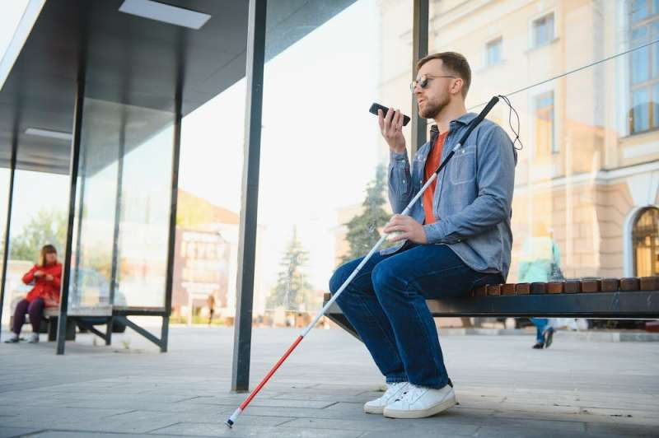

Figure Disabilities people

#### In the software industry

According to (Abiodun Ogunyemi, 2015) People and software are the most important parts of technological society, especially in the era of rapid technological development, the focus on people is also increasing. Software companies create products for human use, so applying HCI to their products is important.



Figure HCI is very important to the software manufacturing industry

#### Community

Although we all know the importance of product usage instructions (Osman Gök, 2019). But it is very difficult for technology products to have complete and easy-to-understand instructions for use, and the percentage of users who take the time to fully read the instructions for use is quite small (especially older people). User need a system that is easy to master after a short period of getting used to it. This is exactly the problem that HCI addresses.

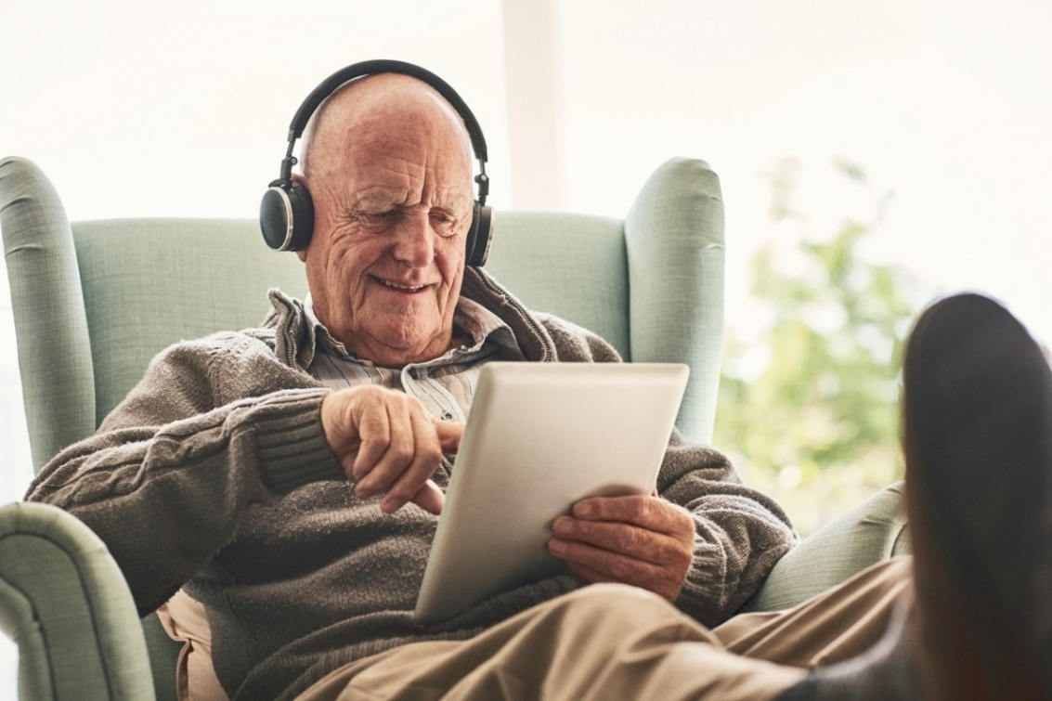

Figure Old-user and technology product

### The process of interaction design

Interaction Design involves 5 stages:

* Find the users’ needs/wants: Find out what users want from your product, based on 3 methods: Observe users; User interviews; Find out what solutions are available
* Analyze the obtained data
* Design solutions to solve the resulting problems
* Create a test prototype
* Realize the end product

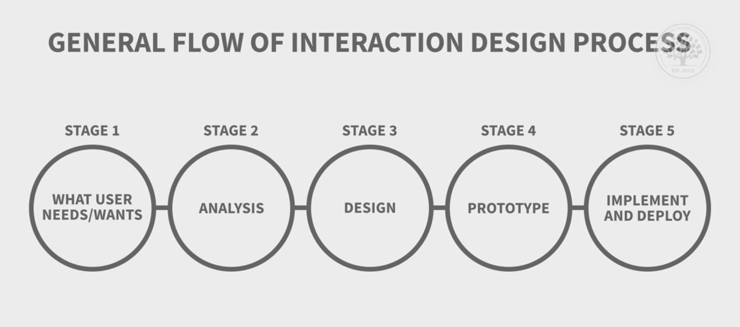

Figure Interaction Design Process

# Product design goals

## Overall my design

Currently, the scuba diving industry has made great progress, most notably diving computers. Today's diving computers display all the parameters users need to have the safest and most enjoyable diving trip. But in addition to displaying parameters, these devices still have many shortcomings. As shown in Figure 11, we can see that their design is not eye-catching, the ability to display parameters in a diving environment is not really good and easy to see, lack of amenities and it is also very cumbersome to wear on the hand.

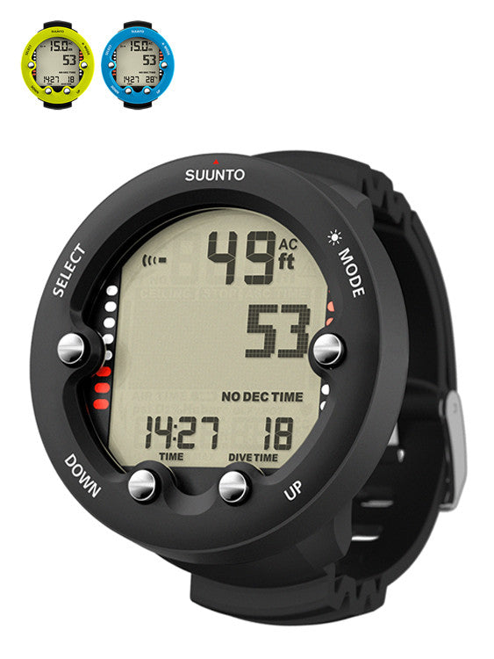

Figure Current Dive computer

In Figure 12, this device solves the problem of being cumbersome in the hand, and the display of parameters is also easier to see, although not enough to be called "good". But in return it is very big and bulky, and its appearance is ugly. And also lacks amenities like the one above.

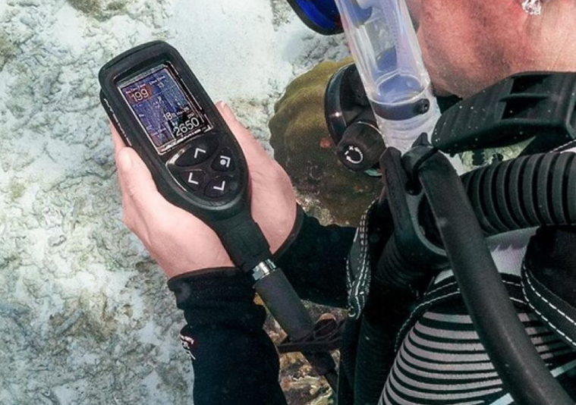

Figure Current Dive computer

And this is the design I created. In addition to displaying parameters like today's diving computers, it also has a few more useful functions for users:

* Record videos, take photos with a camera mounted on a strap
* Visually review captured recordings/photos
* Show more complete parameters
* Has an Always on display screen
* Easy-to-use interface for newbies
* Connect to your phone to:
* Review details of captured recordings/photos
* Automatically update diving statistics and dive history. Displays dive history information
* More beautiful, user-friendly and compact

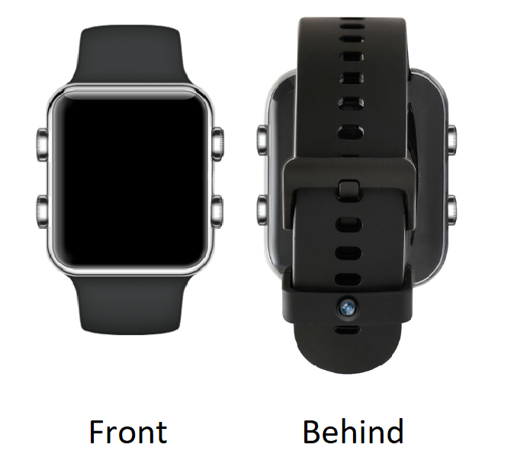

Figure My Dive computer

Why do I say my design is user-friendly? Because its design is based on the model of popular smartwatch models on the market today such as Apple, Samsung, Xiaomi. This design is very familiar to users. The elegance brought from the materials, the meticulousness and refinement of the machining make every angle perfect. Incredible compactness despite integrating a lot of technology. According to (Dempsey, 2015) Apple Watch has almost no space left inside, because the volume of components accounts for almost 95% of the product's physical volume.

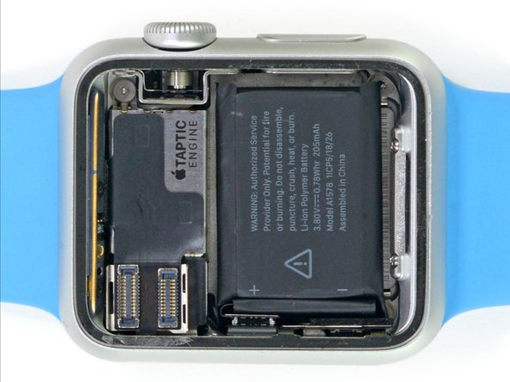

Figure Inside an Apple watch

## Conceptual design

### User requirements

I created a survey from a google form and sent it to divers I know, including a few questions surrounding the current dive computer they are using, from which to draw out the main requirements for the design.

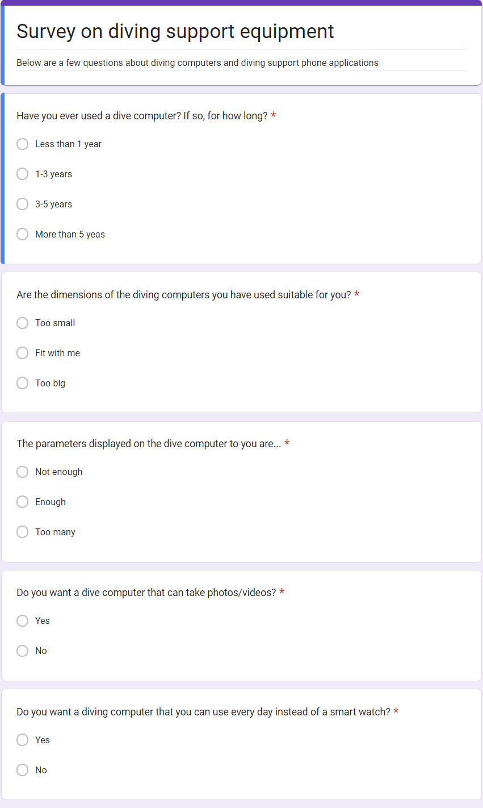

Figure Survey

I then got 10 responses from them; these were from 10 divers who had experience using dive computers.

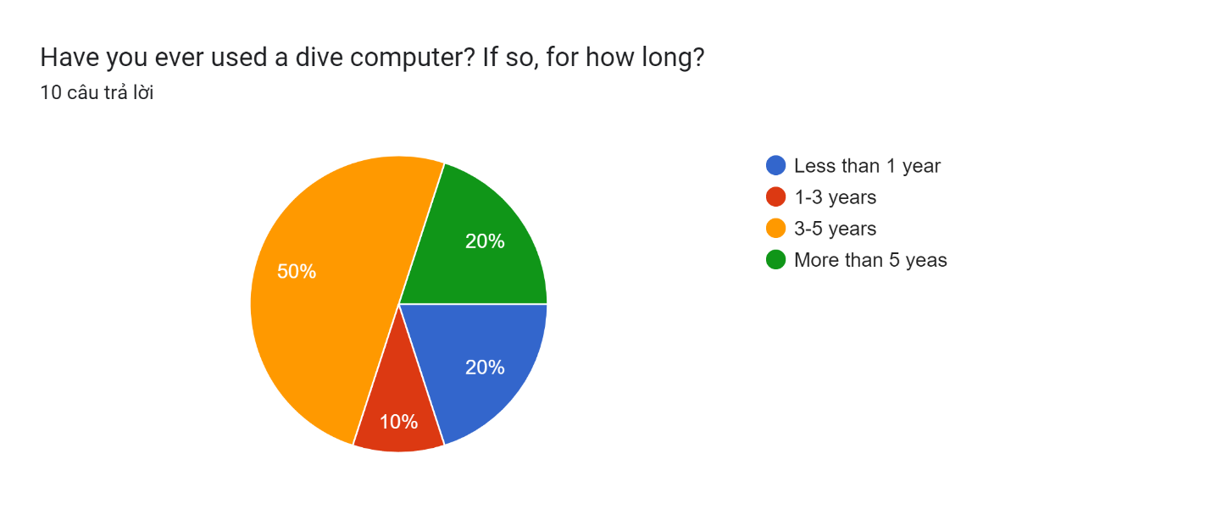

Figure Survey result1

The proportion of long-time users is very high, up to 70% have experience of using for 3 years or more. This shows that the results of the survey are highly practical and so is the success rate of the project.

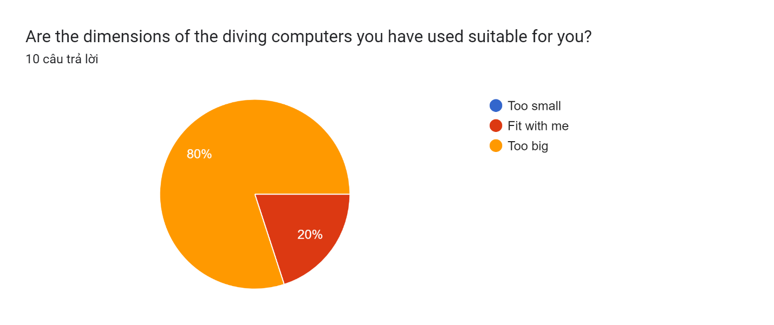

Figure Survey result2

80% of users rated current diving computers as too big when worn on the arm/mounted on the chest. The remaining 20% think it suits them, this is because they haven't seen my design yet, after seeing it they will like the other 80%!

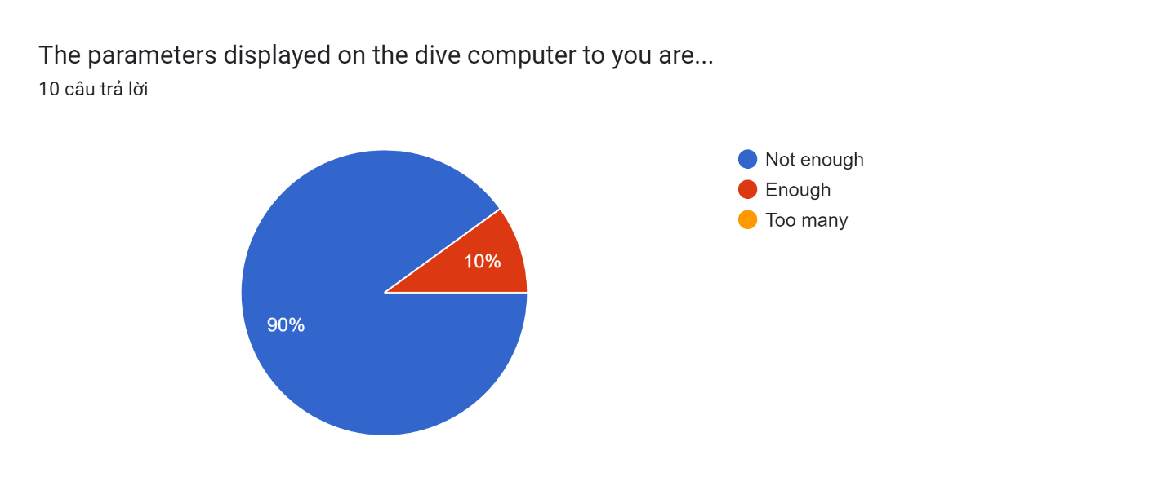

Figure Survey result3

90% think that the number of parameters on current diving computers is not enough, I will create a design that shows many parameters but is still easy to see for users.

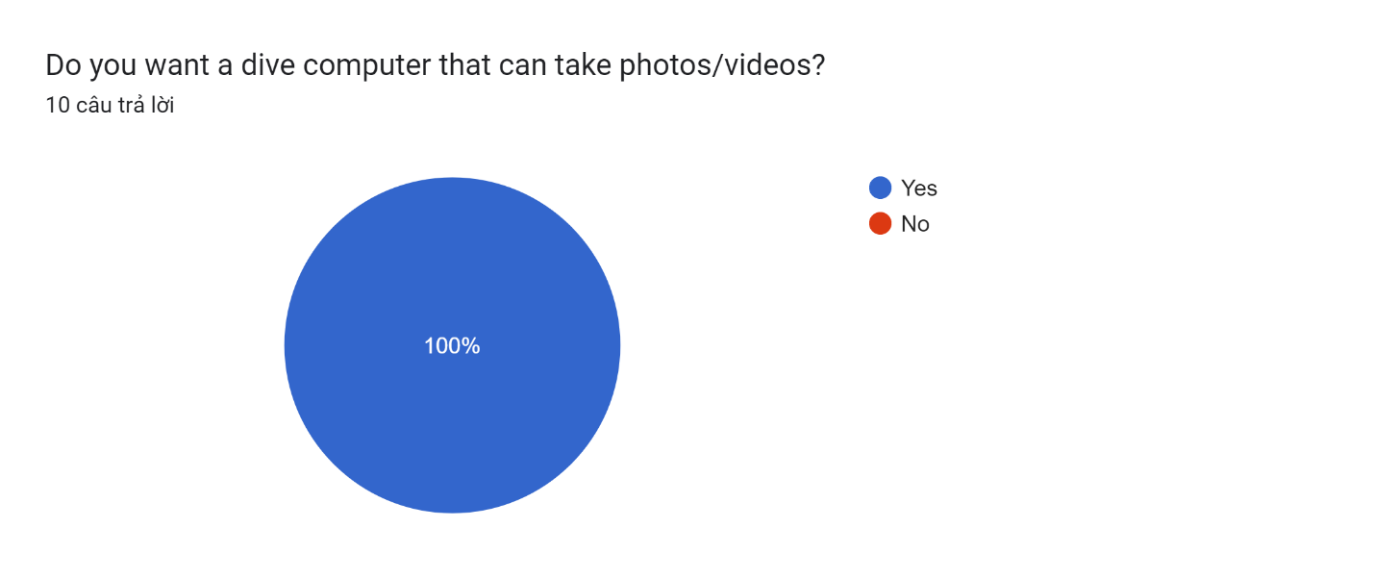

Figure Survey result4

100%, a perfect number! It can be seen that the need to save moments when scuba diving is absolute. For divers, every dive is a beautiful memory, so the need to store images and videos under the sea is essential. I will add a camera to the dive computer in a way that still maintains its elegance and smallness

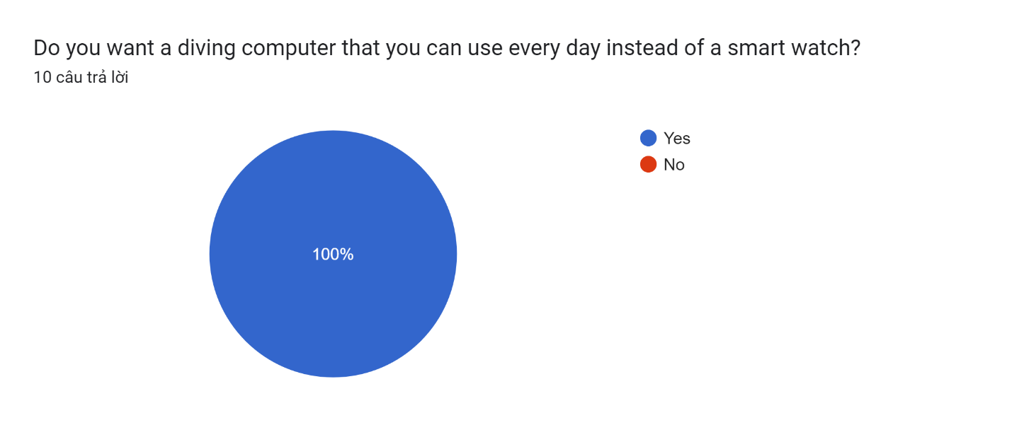

Figure Survey result5

Continue to be 100%. The need for expression and beauty today is not just for women anymore, but for everyone. If there is a device that can be both a diving computer when scuba diving and a smart watch in everyday life, I firmly believe that it is something that have to be created.

I interviewed professional divers living in Da Nang city, their experience of using diving computers in their career is nearly 10 years, and here are the results of 2 interviews of divers Phan Thanh Tra and Phan Anh Ly Ly

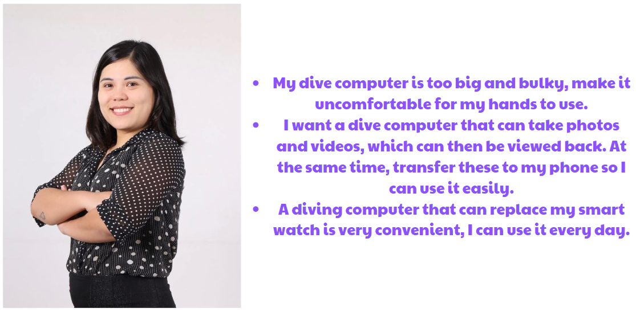

Figure Tra's request

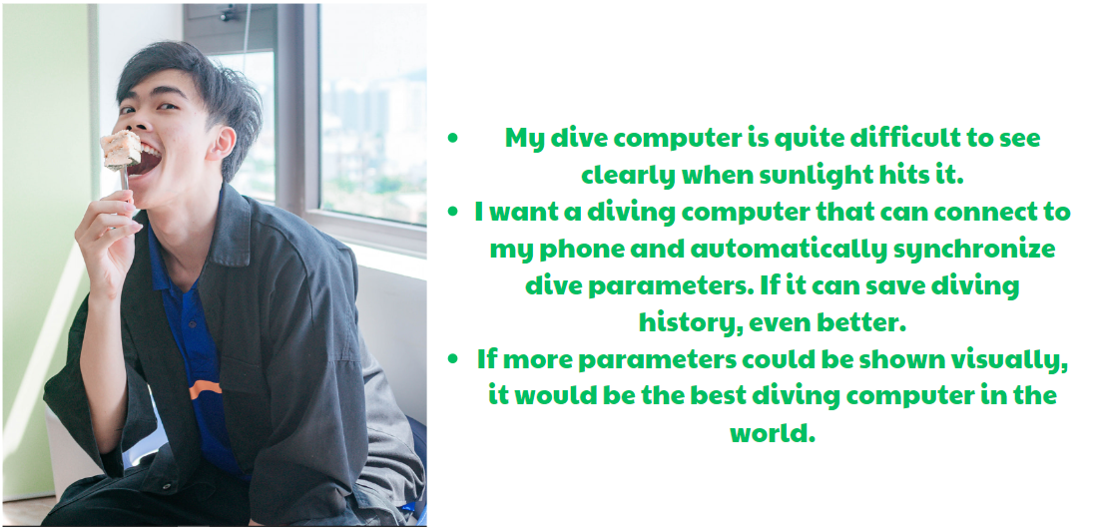

Figure LyLy's request

Thanks to their long experience using dive computers, I was able to create the problems statement and solutions table below.

|  |  |
| --- | --- |
| **Problem** | **Solution** |
| Dive computer is too big and bulky | Make a diving computer as compact as possible |
| Take photos/videos | Attach an additional camera to the strap |
| Synchronize photos/videos and dive parameters/dive history to phone | Use bluetooth to connect the dive computer to the phone, thereby managing albums and dive history/parameters |
| Dificult to see under light | Use a contrasting color palette so it can be easily seen even when it's sunny or very dark |
| Show more parameters visually | Arrange the parameters so that all parameters can be easily displayed for divers to grasp |
| Use instead of smartwatch | Design a beautiful and luxurious product like what big brands have done/are doing |

Table Problems statement and solutions

### Color palette

According to (Alireza Khadir, 2023) We know that color plays an important role in brain perception, so choosing a color palette for design is something I focus on.

To solve the problem of difficulty seeing when the brightness of the environment changes, I will use a strongly contrasting color palette. Here, it is clear that the white-black color palette has the greatest contrast, people can easily see black when it is bright, as well as easily see white when it is dark. In addition, a screen will save more on production costs/energy usage when using black and white.

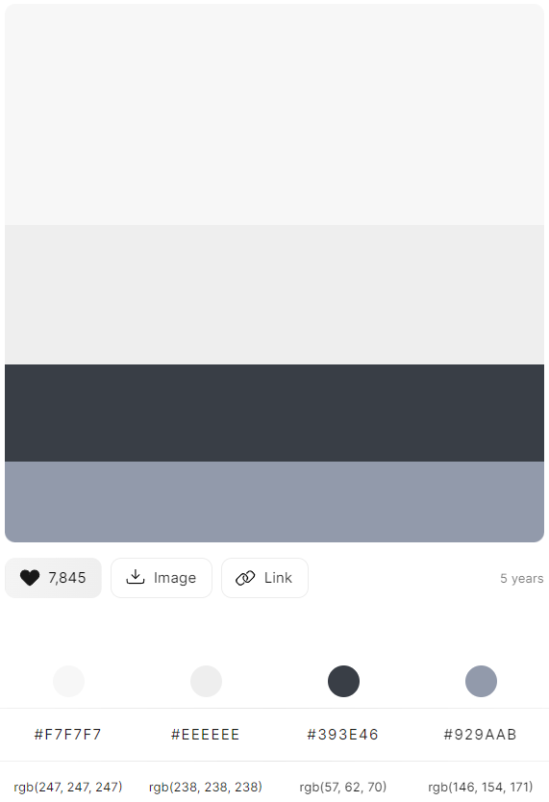

Figure Color palette

White and black can also be suitable for the most demanding customers, but if a product uses many colors, it can be counterproductive for customers who do not like colorful design.

Too many colors can also cause divers to lose concentration in many cases, and this is very dangerous when it is very important to maintain a steady breathing rate, helping the oxygen in the tank to be fully utilized when scuba diving.

## First designs

### Hand-drawn manuscript

One important thing that an HCI researcher should know is that things have become too common, into formal. Designers must understand these things to make their products easy to understand for new users.

For example: Below are the icons that I drew, they have become popular with all users, their recognition is very large. Designers cannot change them (such as using the "+" icon to delete, or using the gear icon to add).

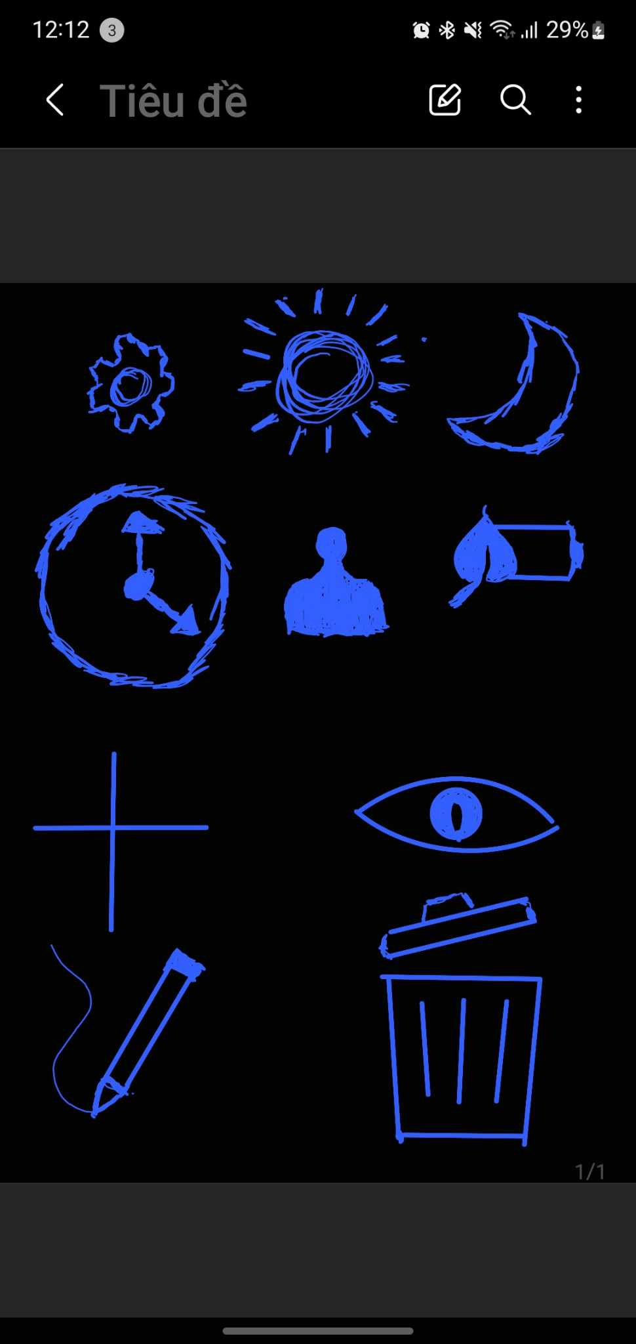

Figure Formal icons every body known

My design will consist of a dive computer and a phone application, With a user-centered design philosophy.

Below are a few home screens of the dive computer and phone app.

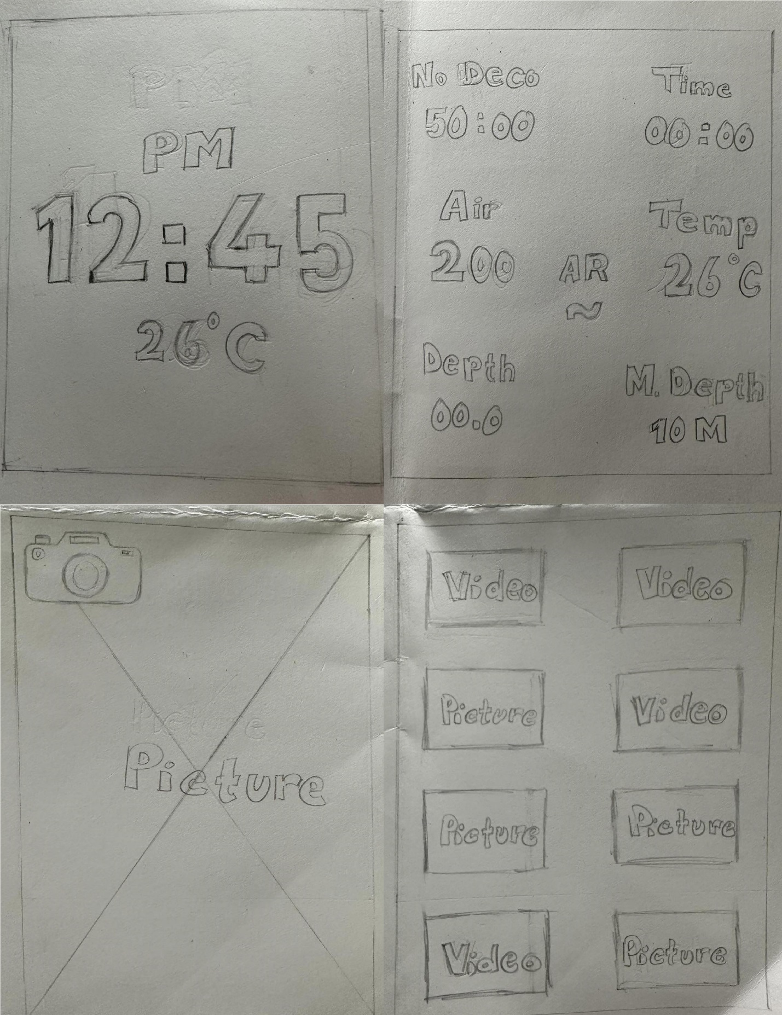

Figure Dive computer screens

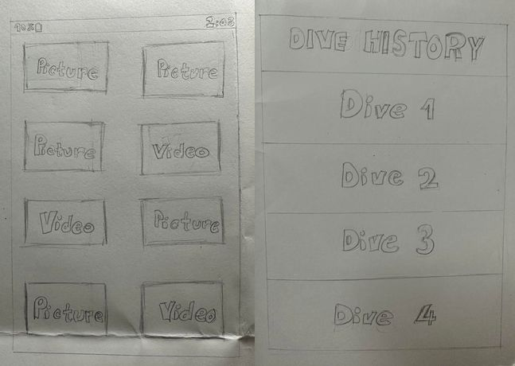

Figure Phone app screens

### Device sketch

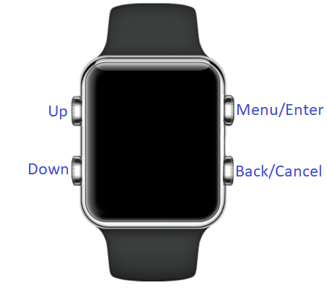

Figure Front of device

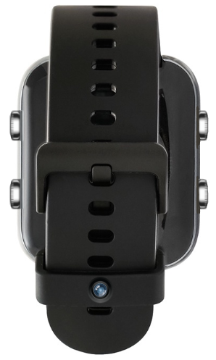

Figure Behind of device

# Final design

## Physical device

For the design to run, we need to have a physical device for users to use, below is the device of the design

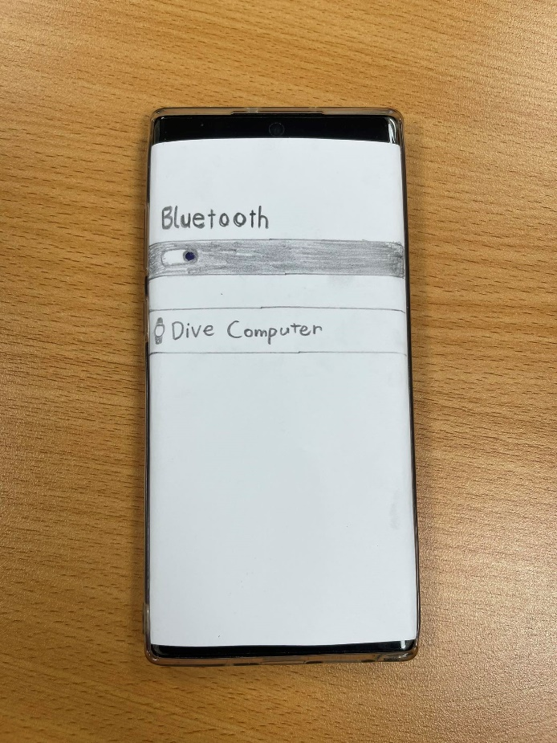

Figure Phone

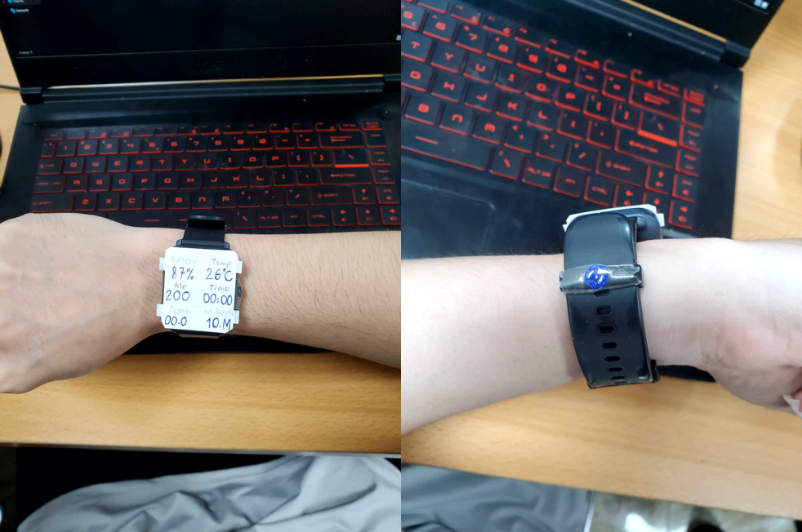

Figure Dive computer

## Axure design

### Dive computer

This is the undive/always on display. It only show the time and current temperature. To get to the main screen, press the menu button.

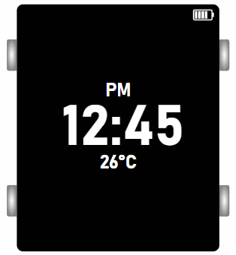

Figure UnDive screen

On the main screen there will be 3 options, move with 2 up and down keys. Whichever option is selected will turn gray with white text to stand out from the remaining options. First try going to the dive screen by pressing the enter button.

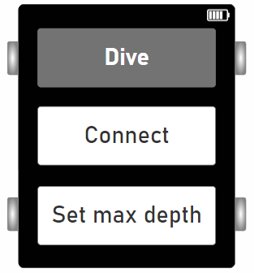

Figure Main screen

Here there will be 7 places to display 8 different parameters:

* Remaining battery level
* No Deco: estimated time to dive.
* Time: Time has set.
* Air: The amount of oxygen remaining in the air tank.
* Temp: Current temperature.
* Depth: Current depth.
* M.Depth: Maximum preset depth.
* AR: Speed, users rely on it to balance the surface speed (under 9m/s)

Now we will try diving, with a maximum depth of 10m.

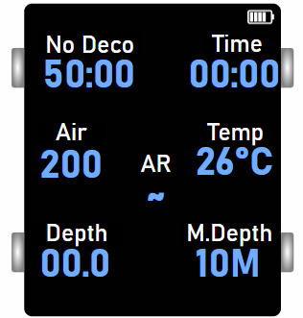

Figure Dive screen

When diving, the parameters will be continuously updated in real time. When the maximum depth is reached, the screen will flash a red warning icon asking the diver to stop there or surface. Now we will try to surface.

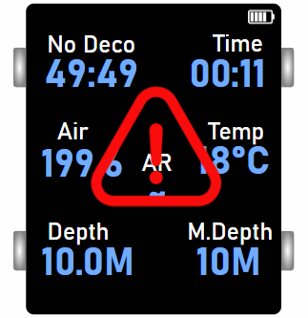

Figure Warning

When it emerges, AR will display for the user to adjust to 9m/s or less. That's it for the diving screen. All parameters are arranged, adjusted in size and color clearly, intuitively and prominently for users to easily observe. Next, press the back button to return to the main screen.

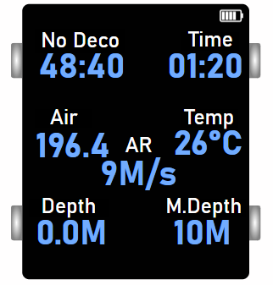

Figure Float up surface

Then press the down button, then enter to enter the connect screen to connect Bluetooth to the phone.

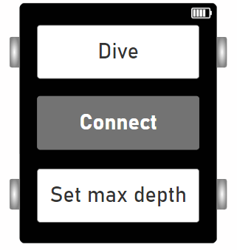

Figure Go to connect

This is the connection screen of the dive computer and phone. Both are turning off Bluetooth.

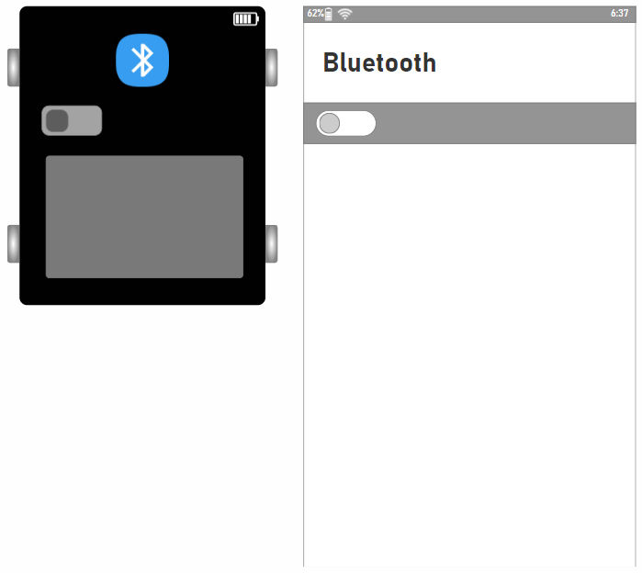

Figure blt off

This is when we turn on bluetooth on only phone.

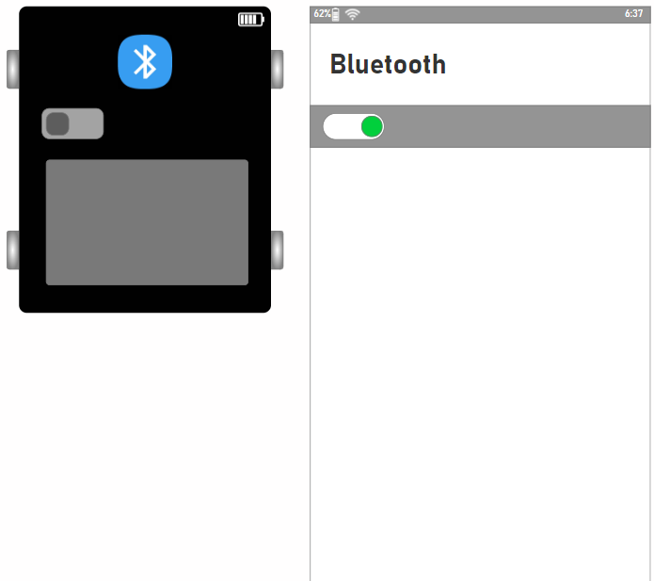

Figure mb blt on

This is when we turn on bluetooth on only dive computer.

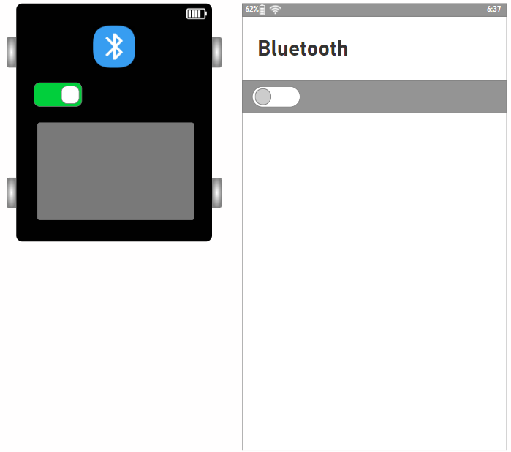

Figure dc blt on

When only 1 device turns on bluetooth, nothing will happen. We must turn on bluetooth on both devices, now both devices can scan the other device.

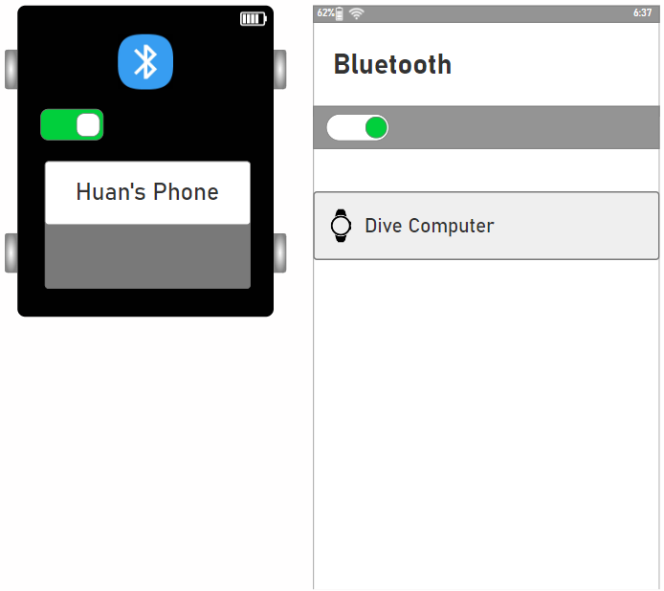

Figure both blt on

Click on the Dive computer device on the phone to request a connection, the diving device screen will display an alert, the user can choose yes to agree or no to refuse.

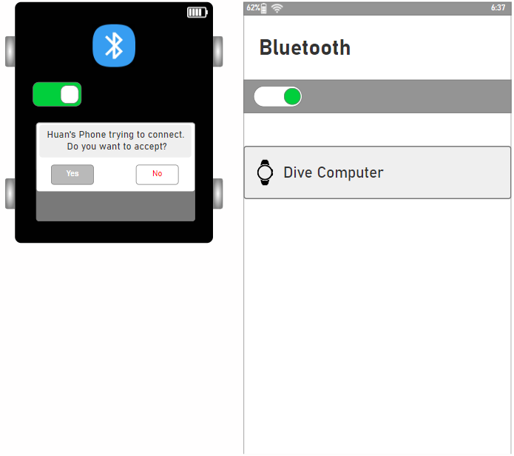

Figure connectRequest

If choose no, it will turn back like before, we need to request connect again, now we choose yes.



Figure connectRefuse

After successful connection, the phone screen will switch to the album, where users can view recorded videos/photos.

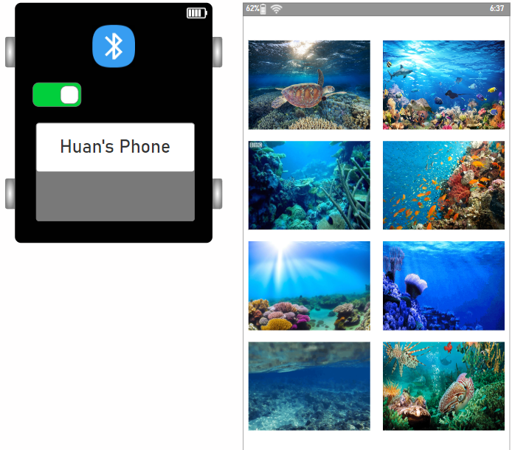

Figure Album phone

If you want to select an image/video, you just need to click on it, it will enlarge it so you can see it more clearly.

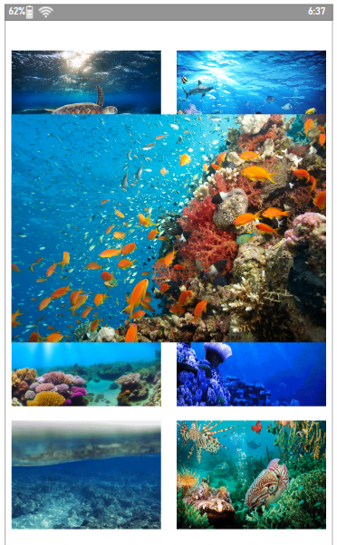

Figure Choose photo

Try with other video.

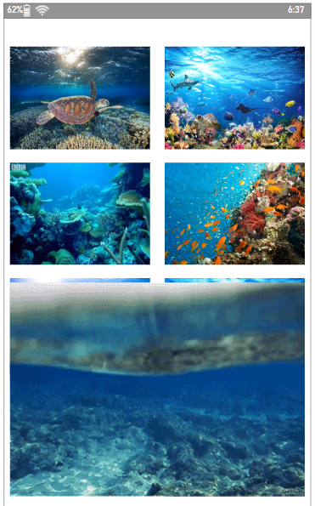

Figure Choose video

Everything works fine. Now long press on the phone screen, the screen will switch to the dive history page. Here, previous dive parameters have been saved, including:

* Diving time
* Average temperature when diving
* Maximum depth achieved
* Average diving depth

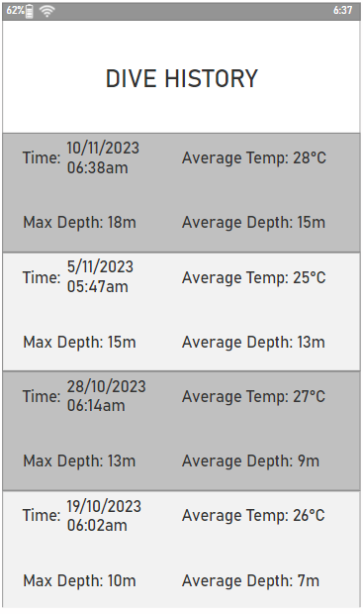

Figure Dive history

To exit, press and hold on an empty area and the album screen returns. That's it, the connection to the phone is complete. Now return to the dive computer screen.

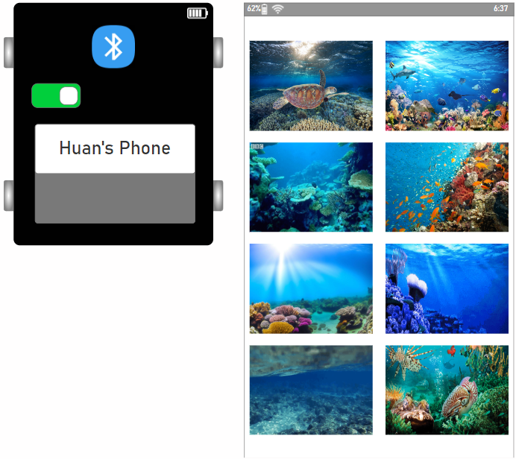

Figure Back to album

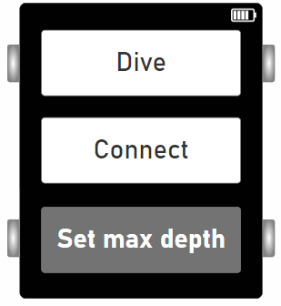

Figure Back main screen

We press the back button to return to the main screen, go to Set max depth and press enter.

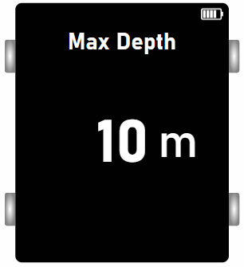

Figure Set max depth

Here, users use the up and down buttons to adjust the maximum depth before diving. Each press will increase/decrease 1m, each press and hold will increase/decrease 10m. For example: To adjust 28m, press and hold the up button 3 times and press the down button 2 times.

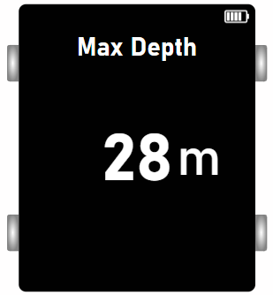

Figure M.depth 28m

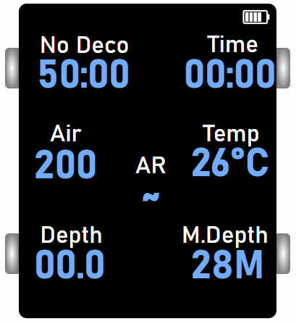

Figure Changed

Now return to the diving screen. So the Max Depth has been adjusted successfully. Next, to enter the photography section, press and hold the menu button.

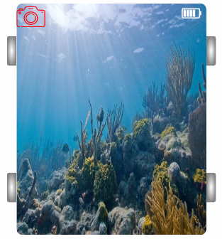

Figure Camera

Press the enter button, the photo will be taken and saved, as we see in picture 52, next to the camera icon is the word "Saving..."

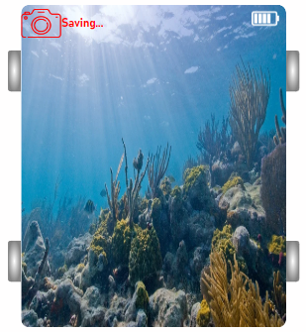

Figure Saving photo

After saving, the word "Saving..." will disappear, letting the user know they can now take a new photo.



Figure Save done

The up and down button will now be used to switch between photo and video recording modes. Let's try switching to video recording. You can see that the camera icon has changed to a recorder.

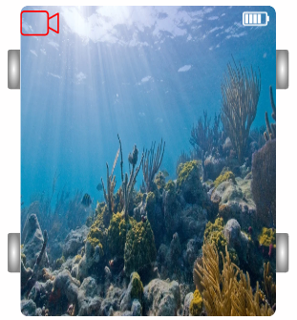

Figure Recoder

When you press the enter button, the camera will record, next to the recorder icon will display the recorded time. At this time, if you want to stop, press enter again, the time will change to "Saving..."

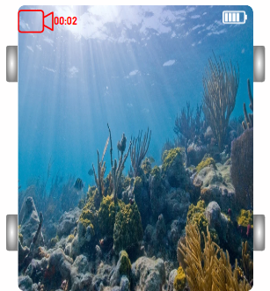

Figure Recording

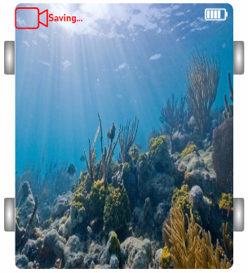

Figure Saving record

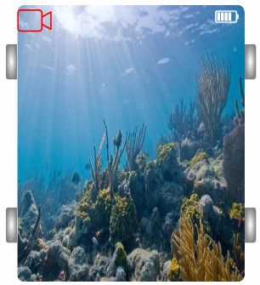

Figure Saving done

When the word "Saving..." disappears, the user can take a new shot. Now let's try going to the visual photo album by holding down the back button. Here, users can only view saved videos/photos visually. If you want to see details, you must use the application on the phone.

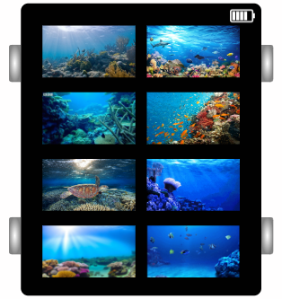

Figure Album1

Use up/down button to see all the photos/videos has been recorded.

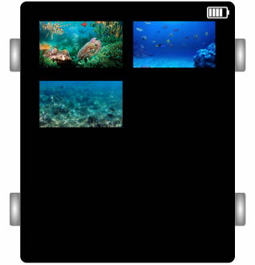

Figure Album2

To return to the diving screen, simply press the back button.

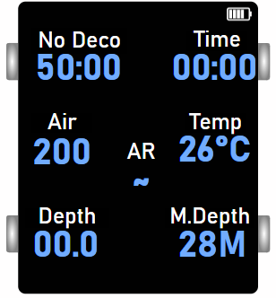

Figure Back to dive screen

## Take feedback

Arcording to (Shute, 2008) Getting feedback from customers directly affects the development direction of the product. After publishing my design, I provided a model for two professional divers Phan Thanh Tra and Phan Anh Ly Ly to use. After 3 months, and more than 10 hours of diving, the two of them sent me some feedback. I have compiled those in the table below.

|  |  |
| --- | --- |
| **Advantage** | **Disadvantage** |
| Compact, unobtrusive | The interface is still a bit simple and unpolished |
| Luxurious, can be used as a smart watch replacement | Colors are not diverse |
| Can take photos/videos and use easily with your phone | Buttons and functions are difficult to use for beginners |
| Diving parameters and diving history are synchronized and automatically saved to the phone |
| The parameters are complete and easy to see | Battery life is quite short |

Table Feedback

# Conclusion

This section is used to summarize the knowledge gained, errors that need to be overcome and improvements for my diving support equipment project.

## Accomplished

* Discuss the theory and materials of Human-computer interactive design.
* Implement design with a user-centered philosophy.
* Collect and analyze user opinions and data.
* Successfully build sketches and physical prototypes for the project according to HCI.
* Successfully produce a full report on the project topic.
* Find the future development direction of the project.

## Limitations/Omissions

* The project's research and survey scale is not large enough, the sample number is only 10 people.
* Limited time, budget, and human resources.
* The knowledge about Human-computer interactive design has not been researched and applied much.
* The physical and electronic design on Axure is not yet perfect.

## Things that can be improved/Foresight of the project

* HCI theories and academic resources can be further researched and applied.
* Survey and consultation objects can be expanded/upgraded.
* Diving computer:
* Improve the disadvantages that users feedback.
* You can connect multiple devices together to share parameters with friends or issue danger warnings to everyone when there is unusual information.
* Launching a modular system that can assemble functions corresponding to each customer's individual needs.

# References

Abiodun Ogunyemi, D. L. E. R. A. &. I. B. d. R., 2015. HCI Practices in the Nigerian Software Industry. In: *Human-Computer Interaction – INTERACT 2015.* s.l.:s.n., pp. 479-488.

Adams, A. & Lunt, P. a. C. P., 2008. Research Methods for Human-Computer Interaction. *qualititative approach to HCI research,* pp. 138-157.

Alireza Khadir, M. M. S. S. G. &. B. B., 2023. Brain activity characteristics of RGB stimulus: an EEG study. *Brain activity characteristics of RGB stimulus: an EEG study,* Volume 13.

Carroll, J. M., 1997. Computer Science Department and Center for Human-Computer Interaction. *HUMAN-COMPUTER INTERACTION: Psychology as a Science of Design,* Volume 48, pp. 61-83.

Dempsey, P., 2015. The teardown: Apple Watch. *Engineering & Technology,* Volume 10, pp. 88-89.

Francisco Nunes, N. V. G. F. M. K. E. G. C. S., 2015. ACM Transactions on Computer-Human Interaction. *Self-Care Technologies in HCI: Trends, Tensions, and Opportunities,* Volume 22, pp. 1-45.

Kolko, J., 2010. *Thoughts on Interaction Design.* s.l.:Thoughts on Interaction Design.

Murphy, M., 2018. *oysterdiving.* [Online]   
Available at: https://oysterdiving.com/blog/what-is-a-dive-computer-how-do-they-work-and-why-do-you-need-one/  
[Accessed 15 Oct 2018].

Osman Gök, P. E. G. B., 2019. The effect of user manual quality on customer satisfaction: the mediating effect of perceived product quality. *Journal of Product & Brand Management,* Volume 28, pp. 475-488.

Ping Zhang, D. F. G., 2015. *Human-computer Interaction and Management Information Systems: Foundations.* London & New York: Routledge.

Rid, 2023. *youtube.* [Online]   
Available at: https://youtu.be/qx2LBlxoyng?si=7Dvnegv8wrtTba7g&t=10

Rid, 2023. *youtube.* [Online]   
Available at: https://youtu.be/qx2LBlxoyng?si=jEOXf55pwUciiKlW&t=134

Shute, V. J., 2008. Focus on Formative Feedback. *Focus on Formative Feedback,* 78(1).